%练习作业

%1. 求以下多项式的商多项式和余数多项式

P1=conv([1 0 1],conv([1 3],[1 1]));

P2=[1 1 0 1];

[q,r]=deconv(P1,P2)

q =

1 3

r =

0 0 1 3 0

%2. 求多项式的根并利用其构造多项式

Q=[1 -4 12 -4 6];

Qr=roots(Q)

QQ=poly(Qr)

Qr =

1.9133 + 2.6681i

1.9133 - 2.6681i

0.0867 + 0.7410i

0.0867 - 0.7410i

QQ =

1.0000 -4.0000 12.0000 -4.0000 6.0000

%3. ，在*n*个节点(*n*不要太大，如取5～11)上用分段线性和三次样条插值方法，计算*m*个插值点(*m* 可取50～100)的函数值。通过数值和图形输出，将两种插值结果与精度值进行比较。适当增加*n*，再作比较。

%n=5;

subplot(2,2,1);

n=5;

m=80;

x=linspace(0,2\*pi,n);

y=sin(x);

t=linspace(0,2\*pi,m);

y1=interp1(x,y,t,'linear');

y2=interp1(x,y,t,'spline');

plot(x,y,':o',t,y1,'-r',t,y2,'-b');

title('n=5');

legend('原始数据','分段线性','三次样条插值');

%n=10

n=10;

subplot(2,2,2);

x=linspace(0,2\*pi,n);

y=sin(x);

t=linspace(0,2\*pi,m);

y1=interp1(x,y,t,'linear');

y2=interp1(x,y,t,'spline');

plot(x,y,':o',t,y1,'-r',t,y2,'-b');

title('n=10');

legend('原始数据','分段线性','三次样条插值');

%n=15

n=15;

subplot(2,2,3);

x=linspace(0,2\*pi,n);

y=sin(x);

t=linspace(0,2\*pi,m);

y1=interp1(x,y,t,'linear');

y2=interp1(x,y,t,'spline');

plot(x,y,':o',t,y1,'-r',t,y2,'-b');

title('n=15');

legend('原始数据','分段线性','三次样条插值');

%n=20

n=20;

subplot(2,2,4);

x=linspace(0,2\*pi,n);

y=sin(x);

t=linspace(0,2\*pi,m);

y1=interp1(x,y,t,'linear');

y2=interp1(x,y,t,'spline');

plot(x,y,':o',t,y1,'-r',t,y2,'-b');

title('n=20');

legend('原始数据','分段线性','三次样条插值');

%精度比较

figure;

suptitle('¾«¶È±È½Ï');

subplot(2,2,1);

title('n=5');

plot(t,detay11,'-r',t,detay21,'-b');

legend('·Ö¶ÎÏßÐÔ','Èý´ÎÑùÌõ²åÖµ');

subplot(2,2,2);

title('n=10');

plot(t,detay12,'-r',t,detay22,'-b');

legend('·Ö¶ÎÏßÐÔ','Èý´ÎÑùÌõ²åÖµ');

subplot(2,2,3);

title('n=15');

plot(t,detay13,'-r',t,detay23,'-b');

legend('·Ö¶ÎÏßÐÔ','Èý´ÎÑùÌõ²åÖµ');

subplot(2,2,4);

title('n=20');

plot(t,detay14,'-r',t,detay24,'-b');

legend('·Ö¶ÎÏßÐÔ','Èý´ÎÑùÌõ²åÖµ');

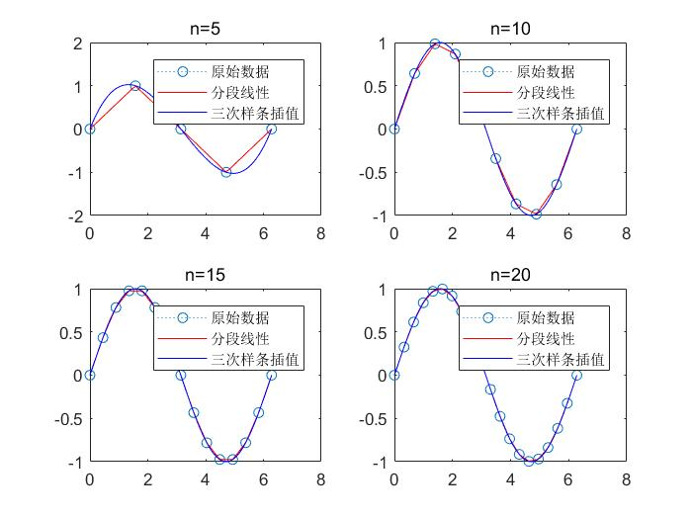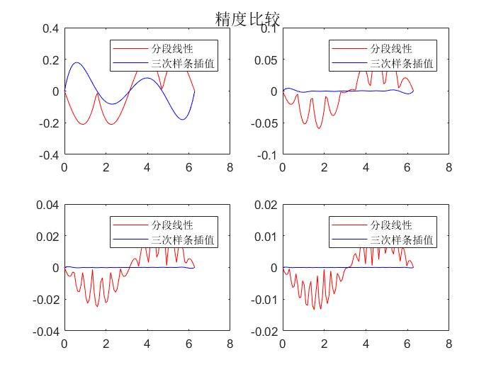

%4.·分别用矩形法、梯形法、辛普森法和科茨4种方法来近似计算定积分

%矩形法

x=linspace(0,1,100);

y=5\*x./(x.^2+4);

w=cumsum(y)\*1/(100-1);

y1=w(100)

%梯形法

y2=trapz(x,y)

%辛普森积分法

y3=quad('5\*x./(x.^2+4)',0,1)

%科茨积分法

y4=quadl('5\*x./(x.^2+4)',0,1)

y1 =

0.5629

y2 =

0.5579

y3 =

0.5579

y4 =

0.5579

%5. 求函数在区间[-5,5]上的最小值和最大值点，并画出其图形

x=-5:0.1:5;

y=4\*x.^3+5\*x.^2+6;

[xmin,fmin]=fminbnd('4\*x^3+5\*x^2+6',-5,5)

[xmax,fm]=fminbnd('-4\*x^3-5\*x^2-6',-5,5);

xmax

fmax=-fm

figure;

plot(x,y);

title('y=4x^{3}+5x^{2}+6');

xmin =

-4.9999

fmin =

-368.9851

xmax =

4.9999

fmax =

630.9791

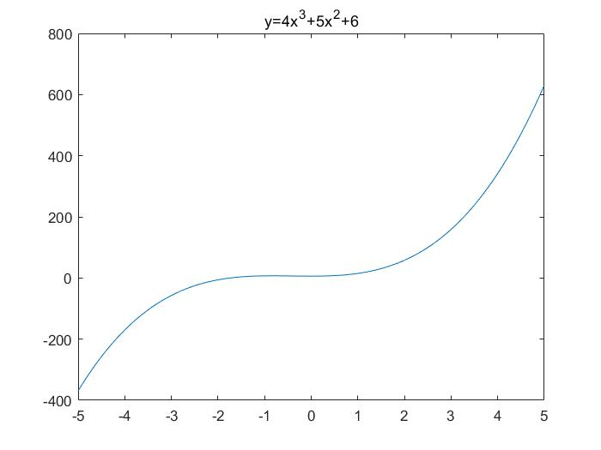

%6. 计算二重积分fun=inline('x\*sin(y)+y\*cos(x)');

S=dblquad(fun,0,pi,pi,2\*pi)

S =

-9.8696

%7. 分别用LU和QR分解法求解线性方程组：

%LU·¨

A=[1 3 -2 1;2 -3 0 2;0 4 2 -3;2 3 -2 -1];

B=[7;5;9;2];

[L,U]=lu(A);

x1=U\(L\B)

%QR·¨

[Q,R]=qr(A);

x2=R\(Q\B)

x1 =

3.0000

3.0000

4.5000

4.0000

x2 =

3.0000

3.0000

4.5000

4.0000

%8. 对以下级数进行求和。



%(1)

syms z

f1=(z+4)/2^z;

I1=symsum(f1,z,1,30)

%(2)

f2=2/(3\*z\*(z+5));

I2=symsum(f2,z,1,inf)

I1 =

1610612727/268435456

I2 =

137/450

%9. 利用二三阶龙格—库塔法（ode23）法来求解下列初值问题。



[x,y]=ode23('fun9',[0:0.1:1.2],1)

figure;

plot(x,y);

title('dy/dx=-2xy y(0)=1');

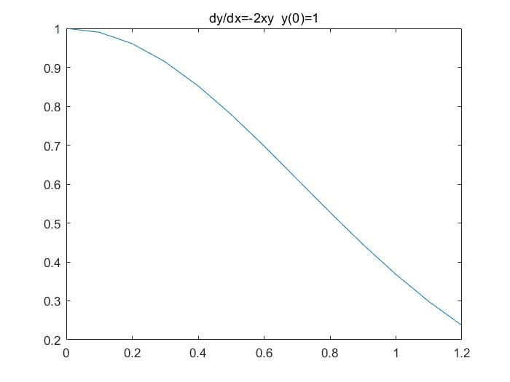

x =

0

0.1000

0.2000

0.3000

0.4000

0.5000

0.6000

0.7000

0.8000

0.9000

1.0000

1.1000

1.2000

y =

1.0000

0.9900

0.9608

0.9139

0.8522

0.7788

0.6977

0.6127

0.5273

0.4449

0.3679

0.2982

0.2369

%练习补充

1、有三个多项式：p1=x^4+2x^3+4x^2+5,

p2=x+2,p3=x^2+2x+3,进行下列操作：

%(1)求P=P1+P2+P3

P1=[1 2 4 0 5];

P2=[0 0 0 1 2];

P3=[0 0 1 2 3];

P=P1+P2+P3

P =

1 2 5 3 10

%(2)求P的根

x=roots(P)

x =

-1.3238 + 1.6529i

-1.3238 - 1.6529i

0.3238 + 1.4578i

0.3238 - 1.4578i

2、求微分方程：

5dy+y=1，y(0)=2的数值解。

[x,y]=ode23('fun10',[0:0.1:10],2)

figure;

plot(x,y);

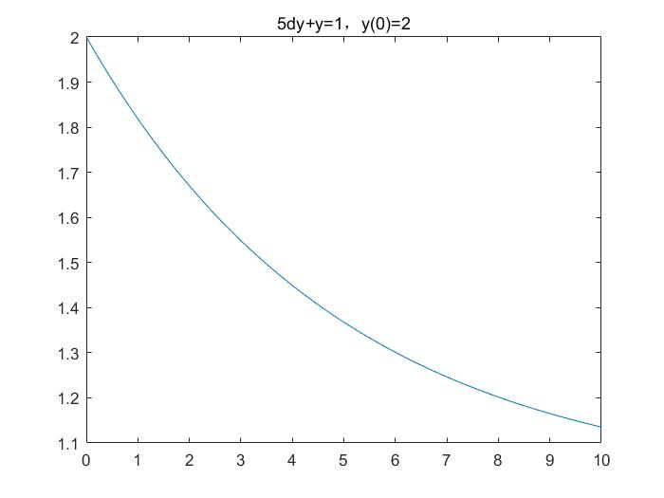

title('5dy+y=1 y(0)=2');

x =

0

0.1000

0.2000

0.3000

0.4000

0.5000

0.6000

0.7000

0.8000

0.9000

1.0000

1.1000

1.2000

1.3000

1.4000

1.5000

1.6000

1.7000

1.8000

1.9000

2.0000

2.1000

2.2000

2.3000

2.4000

2.5000

2.6000

2.7000

2.8000

2.9000

3.0000

3.1000

3.2000

3.3000

3.4000

3.5000

3.6000

3.7000

3.8000

3.9000

4.0000

4.1000

4.2000

4.3000

4.4000

4.5000

4.6000

4.7000

4.8000

4.9000

5.0000

5.1000

5.2000

5.3000

5.4000

5.5000

5.6000

5.7000

5.8000

5.9000

6.0000

6.1000

6.2000

6.3000

6.4000

6.5000

6.6000

6.7000

6.8000

6.9000

7.0000

7.1000

7.2000

7.3000

7.4000

7.5000

7.6000

7.7000

7.8000

7.9000

8.0000

8.1000

8.2000

8.3000

8.4000

8.5000

8.6000

8.7000

8.8000

8.9000

9.0000

9.1000

9.2000

9.3000

9.4000

9.5000

9.6000

9.7000

9.8000

9.9000

10.0000

y =

2.0000

1.9802

1.9608

1.9418

1.9231

1.9048

1.8869

1.8694

1.8521

1.8353

1.8187

1.8025

1.7866

1.7710

1.7557

1.7408

1.7261

1.7117

1.6976

1.6838

1.6702

1.6570

1.6439

1.6312

1.6187

1.6064

1.5944

1.5827

1.5711

1.5598

1.5487

1.5378

1.5272

1.5167

1.5065

1.4965

1.4866

1.4770

1.4676

1.4583

1.4492

1.4403

1.4316

1.4230

1.4147

1.4064

1.3984

1.3905

1.3828

1.3752

1.3678

1.3605

1.3533

1.3463

1.3395

1.3327

1.3262

1.3197

1.3134

1.3072

1.3011

1.2951

1.2893

1.2835

1.2779

1.2724

1.2670

1.2617

1.2565

1.2515

1.2465

1.2416

1.2368

1.2321

1.2275

1.2230

1.2186

1.2143

1.2100

1.2059

1.2018

1.1978

1.1939

1.1900

1.1863

1.1826

1.1790

1.1754

1.1719

1.1685

1.1652

1.1619

1.1587

1.1556

1.1525

1.1495

1.1465

1.1436

1.1408

1.1380

1.1352

%3. 3、对以下级数进行求和。

%(1)

syms z

f1=(z+4)/2^z;

I1=symsum(f1,z,1,30)

%(2)

f2=2/(3\*z\*(z+5));

I2=symsum(f2,z,1,inf)

I1 =

1610612727/268435456

I2 =

137/450

%4. 4、求下列函数在指定区间的最大值

(1) f(x)=(1+x^2)/(1+x^4) x=[0,2]

(2) f(x)=sin(x)+cos(x^2) x=[0,pi]

%(1)f(x)=(1+x^2)/(1+x^4) x=[0,2]

[x1,y1]=fminbnd('-(1+x^2)/(1+x^4)',0,2);

x1

y1max=-y1

%(2)f(x)=sin(x)+cos(x^2) x=[0,pi]

[x2 y2]=fminbnd('-(sin(x)+cos(x^2))',0,pi);

x2

y2max=-y2

x1 =

0.6436

y1max =

1.2071

x2 =

0.7310

y2max =

1.5282

%5. 分别用LU和QR分解法求解线性方程组：

%LU·¨

A=[1 3 -2 1;2 -3 0 2;0 4 2 -3;2 3 -2 -1];

B=[7;5;9;2];

[L,U]=lu(A);

x1=U\(L\B)

%QR·¨

[Q,R]=qr(A);

x2=R\(Q\B)

x1 =

3.0000

3.0000

4.5000

4.0000

x2 =

3.0000

3.0000

4.5000

4.0000